SETUP ENVIRONMENT :

FLASK CREATION

|  |  |
| --- | --- |
| TEAM ID | PNT2022TMID47995 |
| TEAM LEAD | A.Ajitha |
| TEAM MEMBER 01 | G.Pooja |
| TEAM MEMBER 02 | M.Reka |
| TEAM MEMBER 03 | P.Vaishali |

Flask install

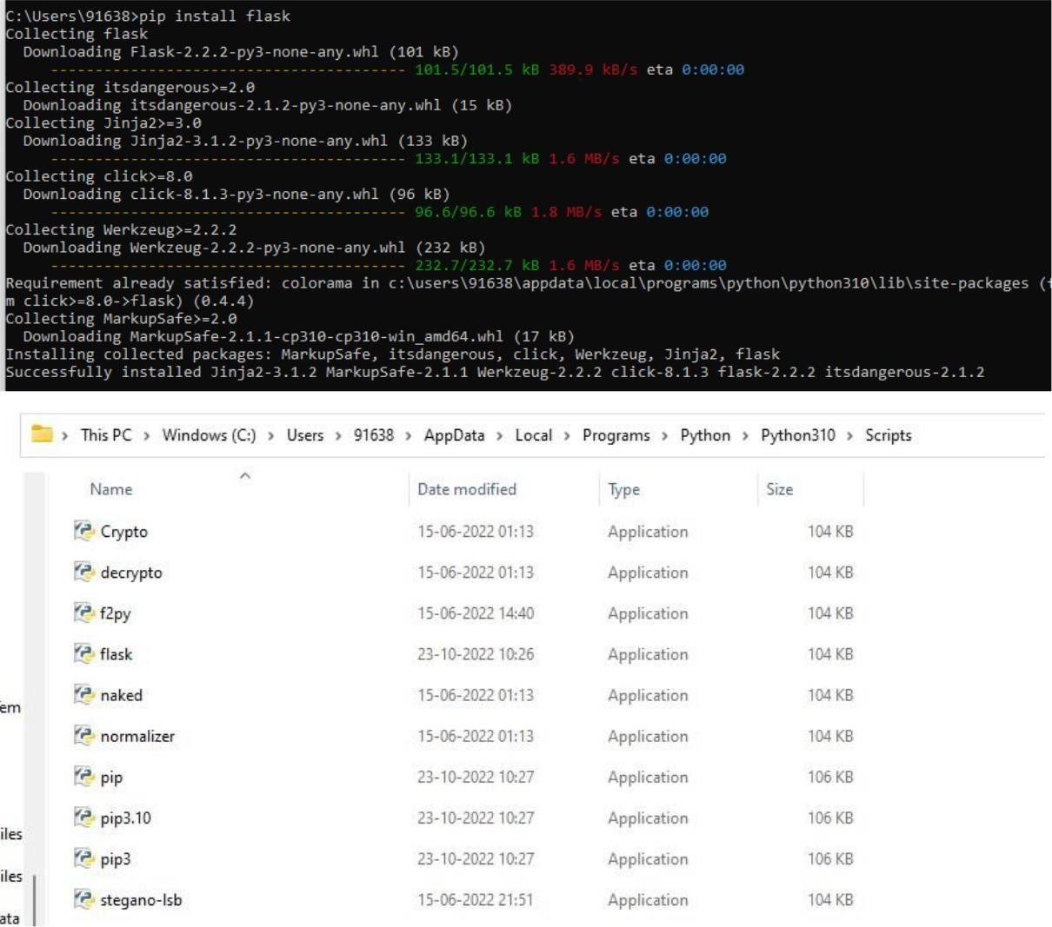

**Create flask:**

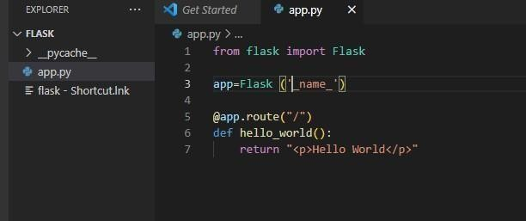

Run flak:

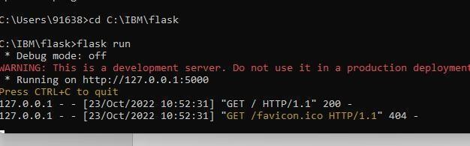

Output

